Music at Zion Lutheran Church

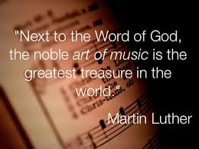
Like all Lutheran churches, worship at Zion is centered upon Word (the Gospel) and Sacrament (Baptism and Holy Communion) and places emphasis on both liturgy and music. What makes the music program at Zion unique is a mixture of musical styles and traditions - the rich 500 year classical Lutheran musical tradition handed down from reformer Martin Luther and composer Johann Sebastian Bach is heard today alongside contemporary anthems, spirituals, gospel music and hymns. The congregation at Zion loves this eclectic mix of music.

Music in worship is led by a talented choir of some 20 singers and two keyboard instruments - an Allen 2-manual electronic organ and a Chickering grand piano. Choir rehearsals take place every Thursday evening 7-8:30 p.m. from late August to early June to prepare the 60 or more anthems sung during services from the first Sunday in September through the second Sunday of June. New choir robes and stoles in the liturgical colors of the church year were purchased in 2015.

Every service at Zion includes at least two selections of special music – sometimes two choir anthems, other times one anthem plus a solo or small group ensemble. Frequently instrumental selections bring the sounds of trumpet, clarinet, oboe, flute, cello and saxophone to the worship space. A guest brass quartet adds a brilliant note to worship and accompanies festive anthems on Reformation and Easter Sundays.

Douglas Bonsall became Zion’s Director of Music in 2012, bringing almost 40 years’ experience in church music leadership.

